COMMON COURSE ASSIGNMENT FORMAT

A. ASSIGNMENT INFORMATION
Particular | Details
Department | Computer Science / Artificial Intelligence and Machine Learning
Programme | B.Tech – Artificial Intelligence and Machine Learning
Course Code & Course Name | CSA0311-Data Structures
Academic Year / Batch | 2nd year-2025 Batch
Faculty Name | Dr.K.Kiruthika
Assignment Title | Real-Time Emergency Vehicle Routing System Using Dijkstra’s Algorithm, Min-Heap, HashMap and HashSet
Student Names | P. Sai Ganesh Reddy, Ubed, Harsha
Roll Numbers | 192525111, 192525115, 192525108
Date of Issue | 31/08/2026
Date of Submission | 31/08/2026
Maximum Marks | 100
Bloom’s Taxonomy Level | L4 – Analyze, L5 – Evaluate
SDG Mapping | SDG 11 – Sustainable Cities and Communities

B. ASSIGNMENT PROBLEM / CHALLENGE
Modern cities contain large and complex road networks consisting of thousands of intersections and roads. During emergency situations, vehicles such as ambulances, fire engines and police vehicles need to reach their destinations as quickly as possible.
The major challenge is that the shortest physical distance is not always the most suitable route. Different roads may have different distances and traffic conditions. A road with a shorter distance may be heavily congested, while another slightly longer road may provide faster travel.
Therefore, an efficient emergency vehicle routing system is required to determine a suitable route between the current location of an emergency vehicle and the destination.
The proposed system models the city road network as a weighted graph. Intersections are represented as vertices, roads are represented as edges, and distance or travel cost is represented as the edge weight.
The system is designed to handle a large road network containing more than 5,000 intersections and 10,000 roads. It should generate a route efficiently, with a target route-generation time of approximately 200 ms, while maintaining moderate memory usage.
The project investigates different data structures and algorithms such as:
- Adjacency Matrix
- Adjacency List
- Breadth-First Search
- Dijkstra’s Algorithm
- Floyd-Warshall Algorithm
- Min-Heap
- Priority Queue
- HashMap
- HashSet
After comparing the alternatives, Dijkstra’s Algorithm with a Min-Heap is selected as the main shortest-path solution.
C. PROBLEM STATEMENT
A smart-city traffic management company is developing a Real-Time Emergency Vehicle Routing System for ambulances, fire engines and other emergency vehicles.
The system receives road-network information consisting of:
- Intersections
- Roads
- Road distances
- Traffic conditions
- Emergency vehicle location
- Emergency destination
The system must calculate the shortest available route between the emergency vehicle's current location and the destination.
The proposed system should:
- Handle more than 5,000 intersections.
- Handle more than 10,000 roads.
- Generate routes efficiently.
- Target route computation within approximately 200 ms.
- Select the shortest weighted route.
- Support changing traffic conditions.
- Support repeated route queries.
- Maintain reasonable memory consumption.
- Avoid unnecessary processing of already visited intersections.
- Display the selected route and total distance/cost.
The system uses Dijkstra’s Algorithm for shortest-path calculation and a Min-Heap as the priority queue. HashMap and HashSet concepts are incorporated for efficient information management and visited-node tracking.
D. REQUIREMENTS AND CONSTRAINTS
D.1 Functional Requirements
1. Road Network Input
The system must accept the number of intersections and roads in the city network.
2. Road Information
For every road, the following information can be provided:
- Source intersection
- Destination intersection
- Road distance
- Traffic condition, where applicable
3. Source Location
The current intersection of the emergency vehicle is provided as the source.
4. Destination Location
The emergency location or destination intersection is provided.
5. Shortest Route Calculation
The system calculates the minimum-cost route between the source and destination.
6. Route Display
The complete route should be displayed in sequential order.
Example:
0 → 2 → 1 → 3 → 4
7. Total Distance
The total distance or effective travel cost should be displayed.
8. Traffic Updates
The proposed architecture should allow traffic conditions to be updated so that route costs can change dynamically.
9. Multiple Queries
The system should support repeated routing requests.
D.2 Performance Requirements
The proposed system should be capable of handling:
- More than 5,000 intersections.
- More than 10,000 roads.
- Weighted edges.
- Repeated route requests.
- Changing road conditions.
The target route-generation time is approximately 200 ms.
D.3 Memory Requirements
A large road network can consume considerable memory if an adjacency matrix is used.
For V vertices, an adjacency matrix requires:
O(V²) space.
An adjacency list requires:
O(V + E) space.
Therefore, an adjacency-list representation is more suitable for a large and relatively sparse city road network.
D.4 Technical Constraints
The system has the following constraints:
- Dijkstra’s algorithm requires non-negative edge weights.
- Distance values must be initialized correctly.
- The Min-Heap must maintain the minimum-heap property.
- Parent information must be maintained.
- Visited nodes should not be unnecessarily processed.
- Invalid intersection identifiers must be avoided.
- Unreachable destinations must be detected.
- Traffic updates should correctly modify effective route costs.
D.5 Safety and Reliability
Emergency routing is a safety-sensitive application. Incorrect routing can increase response time.
Therefore, the system must be tested using:
- Different graph sizes.
- Different source and destination combinations.
- Unreachable nodes.
- Multiple alternative routes.
- Different road weights.
- Changing traffic conditions.
The system should be thoroughly validated before being considered for real-world emergency deployment.
E. STUDENT WORK
1. PROBLEM UNDERSTANDING AND FORMULATION
1.1 Understanding the Problem
The city road network is represented using a weighted graph.
The basic graph representation is:
G = (V, E)
where:
- V represents intersections.
- E represents roads.
- Weight represents distance or travel cost.
For example:
4
0 -------- 1
| |
2| |5
| |
2 -------- 3
|
|2
|
4
The routing problem is to find a path from a source vertex to a destination vertex with minimum total weight.
1.2 Expected Outcome
The expected outcome of the project is a routing system capable of:
- Finding a shortest route.
- Calculating total distance.
- Processing weighted roads.
- Handling large road networks.
- Supporting repeated queries.
- Considering traffic information.
- Reconstructing the complete route.
- Detecting unreachable destinations.
1.3 Input Data
The system accepts:
Number of intersections
Number of roads
Road source
Road destination
Road distance
Source location
Destination location
Traffic-aware versions can additionally accept:
Traffic condition
Traffic cost
Road availability
1.4 Output Data
The system produces:
Shortest Route
Total Distance / Cost
If no path exists:
No route available.
Example:
Shortest Route: 0 -> 2 -> 1 -> 3 -> 4
Total Distance: 10
1.5 Assumptions
The following assumptions are used:
- Each intersection has a unique identification number.
- Road distances are non-negative.
- The road network can be represented as a graph.
- The demonstration program treats roads as bidirectional.
- A valid source and destination are provided.
- The graph contains valid intersection numbers.
- The edge weight represents distance or cost.
- Traffic cost can be incorporated into the effective edge weight.

2. APPLICATION OF COURSE KNOWLEDGE
2.1 Graph Data Structure
Graphs are used to represent the road network.
Each intersection becomes a vertex:
Intersection = Vertex
Each road becomes an edge:
Road = Edge
Distance becomes:
Edge Weight = Distance
This provides a direct mathematical representation of the city transportation network.
2.2 Dijkstra’s Algorithm
Dijkstra’s Algorithm is the main algorithm used to find the shortest path.
Initially:
distance[source] = 0
and all other distances are set to infinity:
distance[other nodes] = ∞
The algorithm then repeatedly selects the node with the smallest current distance.
For every neighbouring node:
New Distance = Current Distance + Edge Weight
If the new distance is smaller than the existing distance, the distance is updated.
2.3 Min-Heap
A Min-Heap is used as the priority queue.
The Min-Heap ensures that the node with the smallest current distance is selected first.
Main operations are:
- Insert.
- Extract minimum.
- Heapify / restructure.
The use of a Min-Heap improves the efficiency of repeated minimum-distance selection.
2.4 HashMap
HashMap can be used to store:
- Intersection information.
- Adjacency information.
- Traffic information.
- Road status.
Conceptually:
TrafficMap[Road] = TrafficCondition
This allows quick access to traffic-related information.
2.5 HashSet
A HashSet can store intersections that have already been processed.
Conceptually:
Visited = {0, 2, 1}
Before processing an intersection, the system checks whether it has already been visited.
The demonstration C implementation uses a visited[] array for this purpose.
2.6 Parent Array
The parent array stores the predecessor of every node.
Example:
parent[4] = 3
parent[3] = 1
parent[1] = 2
parent[2] = 0
The route can be reconstructed as:
4 ← 3 ← 1 ← 2 ← 0
Final route:
0 → 2 → 1 → 3 → 4

3. SOLUTION / DESIGN / METHODOLOGY
3.1 Overall System Architecture
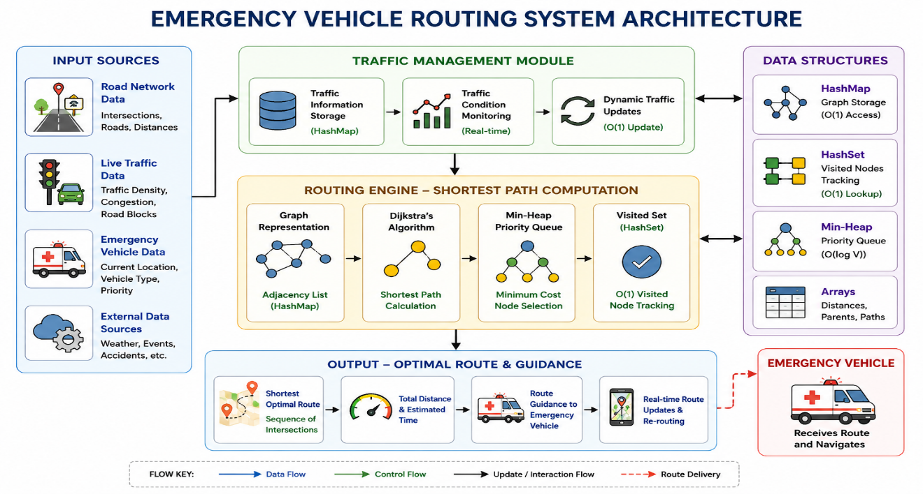

3.2 Graph Construction
The graph is created by reading the road information.
For an undirected road:
u → v
v → u
If:
Road = 0 to 1
Distance = 4
then:
graph[0][1] = 4
graph[1][0] = 4
3.3 Traffic Management
Traffic can be represented using different conditions.
Traffic | Example Cost
Low | 1
Medium | 3
High | 5
The effective route cost can be calculated as:
Effective Cost = Road Distance + Traffic Cost
For example:
Road Distance = 10
Traffic Cost = 3

Effective Cost = 10 + 3
= 13
This allows the routing algorithm to consider traffic in addition to physical distance.

3.4 Dijkstra Processing
The process is:
1. Initialize distances.
2. Set source distance to 0.
3. Insert source into Min-Heap.
4. Extract minimum-distance node.
5. Mark it as visited.
6. Examine all neighbouring nodes.
7. Calculate new distances.
8. Update distance if a shorter route is found.
9. Update parent.
10. Insert updated node into Min-Heap.
11. Continue until the destination is reached or the heap becomes empty.
12. Reconstruct and display the route.
4. ALGORITHM
4.1 Dijkstra Algorithm
Algorithm Dijkstra(Graph, Source, Destination)
1. For every vertex v:
distance[v] = INFINITY
parent[v] = -1
visited[v] = false
2. distance[Source] = 0
3. Insert Source into Min-Heap
4. While Min-Heap is not empty:

u = Extract-Min()
If visited[u] == true:
Continue
visited[u] = true
For every neighbour v of u:
newDistance =
distance[u] + weight(u,v)
If newDistance < distance[v]:
distance[v] = newDistance
parent[v] = u
Insert v into Min-Heap
5. If distance[Destination] == INFINITY:
Display "No route available"
6. Otherwise:
Reconstruct path using parent[]
7. Display shortest route
8. Display total distance

5. PSEUDOCODE
START
Read number of intersections N
Read number of roads E
Create graph
FOR each road:
Read source
Read destination
Read distance
Add road to graph
END FOR
Read emergency vehicle source
Read emergency destination
FOR every intersection:
distance = INFINITY
parent = -1
visited = false
distance[source] = 0
Create empty Min-Heap
Insert source into Min-Heap
WHILE Min-Heap is not empty:
current = Extract-Min()
IF current is already visited:
CONTINUE
Mark current as visited
FOR every neighbour:
newDistance =
distance[current] + edgeWeight
IF newDistance < distance[neighbour]:
distance[neighbour] = newDistance
parent[neighbour] = current

Insert neighbour into Min-Heap
END WHILE
IF destination distance is INFINITY:
Print "No route available"
ELSE:
Reconstruct route using parent array
Print route
Print total distance
STOP

6. FLOWCHART
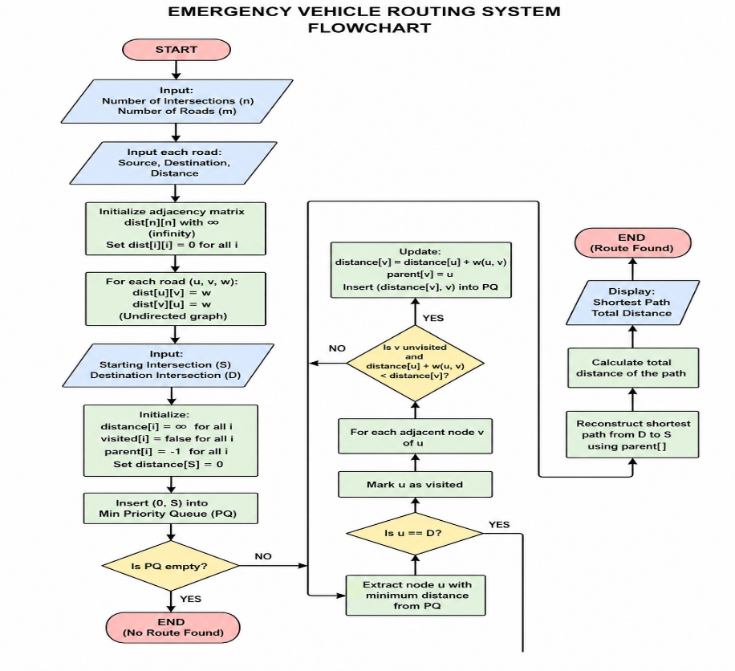

7. IMPLEMENTATION / SOURCE CODE
The following C program implements the main routing mechanism using a graph, Min-Heap, distance array, parent array and visited array.
#include <stdio.h>
#include <stdlib.h>
#define MAX 50
#define INF 99999
int graph[MAX][MAX];
int dist[MAX];
int visited[MAX];
int parent[MAX];
int heap[MAX * MAX];
int heapDist[MAX * MAX];
int heapSize;
void insertHeap(int node, int distance)
{
int i, p;
int tempNode, tempDist;
i = heapSize;
heap[i] = node;
heapDist[i] = distance;
heapSize++;
while (i > 0)
{
p = (i - 1) / 2;
if (heapDist[p] <= heapDist[i])
break;
tempNode = heap[p];
heap[p] = heap[i];
heap[i] = tempNode;
tempDist = heapDist[p];
heapDist[p] = heapDist[i];
heapDist[i] = tempDist;
i = p;
}
}
int removeHeap()
{
int node;
int lastNode, lastDist;
int i, left, right, smallest;
node = heap[0];
heapSize--;
if (heapSize == 0)
return node;
lastNode = heap[heapSize];
lastDist = heapDist[heapSize];
heap[0] = lastNode;
heapDist[0] = lastDist;
i = 0;
while (1)
{
left = 2 * i + 1;
right = 2 * i + 2;
smallest = i;
if (left < heapSize &&
heapDist[left] < heapDist[smallest])
{
smallest = left;
}
if (right < heapSize &&
heapDist[right] < heapDist[smallest])
{
smallest = right;
}
if (smallest == i)
break;
lastNode = heap[i];
heap[i] = heap[smallest];
heap[smallest] = lastNode;
lastDist = heapDist[i];
heapDist[i] = heapDist[smallest];
heapDist[smallest] = lastDist;
i = smallest;
}
return node;
}
void dijkstra(int n, int source, int destination)
{
int i, j, u;
int newDistance;
int path[MAX];
int pathCount;
int current;
for (i = 0; i < n; i++)
{
dist[i] = INF;
visited[i] = 0;
parent[i] = -1;
}
heapSize = 0;
dist[source] = 0;
insertHeap(source, 0);
while (heapSize > 0)
{
u = removeHeap();
if (visited[u] == 1)
continue;
visited[u] = 1;
for (j = 0; j < n; j++)
{
if (graph[u][j] > 0)
{
if (visited[j] == 0)
{
newDistance =
dist[u] + graph[u][j];
if (newDistance < dist[j])
{
dist[j] = newDistance;
parent[j] = u;
insertHeap(j, dist[j]);
}
}
}
}
}
if (dist[destination] == INF)
{
printf("\nNo route available.\n");
return;
}
pathCount = 0;
current = destination;
while (current != -1)
{
path[pathCount] = current;
pathCount++;
current = parent[current];
}

printf("\n====================================\n");
printf(" EMERGENCY ROUTING RESULT\n");
printf("====================================\n");
printf("Shortest Route: ");
for (i = pathCount - 1; i >= 0; i--)
{
printf("%d", path[i]);

if (i != 0)
printf(" -> ");
}
printf("\nTotal Distance: %d\n",
dist[destination]);
printf("====================================\n");
}
int main()
{
int n, e;
int i;
int u, v;
int distance;
int source, destination;
printf("====================================\n");
printf(" EMERGENCY VEHICLE ROUTING SYSTEM\n");
printf("====================================\n");
printf("\nEnter number of intersections: ");
scanf("%d", &n);
printf("Enter number of roads: ");
scanf("%d", &e);
for (i = 0; i < e; i++)
{
printf("\nRoad %d\n", i + 1);

printf("Source: ");
scanf("%d", &u);
printf("Destination: ");
scanf("%d", &v);
printf("Distance: ");
scanf("%d", &distance);
graph[u][v] = distance;
graph[v][u] = distance;
}
printf("\nEnter emergency vehicle starting point: ");
scanf("%d", &source);
printf("Enter emergency destination: ");
scanf("%d", &destination);
dijkstra(n, source, destination);
return 0;
}

8. TEST CASES AND EXPECTED / ACTUAL RESULTS
Test Case | Source | Destination | Expected Result | Actual Result
TC01 | 0 | 4 | Shortest route should be displayed | Route calculated successfully
TC02 | 0 | 3 | Minimum-distance path should be selected | Shortest path calculated
TC03 | 0 | 2 | Direct/shortest path should be selected | Shortest path calculated
TC04 | 1 | 4 | Route from intersection 1 to 4 | Route calculated
TC05 | 4 | 0 | Reverse route should be available for the undirected graph | Route calculated
TC06 | Disconnected node | Any node | System should display no route | “No route available”

9. SAMPLE INPUT
Enter number of intersections: 50
Enter number of roads: 100

Road 1
Source: 0
Destination: 1
Distance: 4

Road 2
Source: 0
Destination: 2
Distance: 7

Road 3
Source: 0
Destination: 5
Distance: 12

Road 4
Source: 1
Destination: 2
Distance: 3

Road 5
Source: 1
Destination: 6
Distance: 8

Road 6
Source: 1
Destination: 10
Distance: 15

Road 7
Source: 2
Destination: 3
Distance: 5

Road 8
Source: 2
Destination: 7
Distance: 6

Road 9
Source: 2
Destination: 11
Distance: 14

Road 10
Source: 3
Destination: 4
Distance: 2

Road 11
Source: 3
Destination: 8
Distance: 9

Road 12
Source: 3
Destination: 12
Distance: 11

Road 13
Source: 4
Destination: 9
Distance: 7

Road 14
Source: 4
Destination: 13
Distance: 13

Road 15
Source: 5
Destination: 6
Distance: 4

Road 16
Source: 5
Destination: 10
Distance: 9

Road 17
Source: 5
Destination: 15
Distance: 10

Road 18
Source: 6
Destination: 7
Distance: 2

Road 19
Source: 6
Destination: 11
Distance: 8

Road 20
Source: 6
Destination: 16
Distance: 12

Road 21
Source: 7
Destination: 8
Distance: 3

Road 22
Source: 7
Destination: 12
Distance: 7

Road 23
Source: 7
Destination: 17
Distance: 9

Road 24
Source: 8
Destination: 9
Distance: 4

Road 25
Source: 8
Destination: 13
Distance: 10

Road 26
Source: 8
Destination: 18
Distance: 8

Road 27
Source: 9
Destination: 14
Distance: 6

Road 28
Source: 9
Destination: 19
Distance: 11

Road 29
Source: 10
Destination: 11
Distance: 5

Road 30
Source: 10
Destination: 15
Distance: 6

Road 31
Source: 10
Destination: 20
Distance: 14

Road 32
Source: 11
Destination: 12
Distance: 3

Road 33
Source: 11
Destination: 16
Distance: 7

Road 34
Source: 11
Destination: 21
Distance: 13

Road 35
Source: 12
Destination: 13
Distance: 4

Road 36
Source: 12
Destination: 17
Distance: 6

Road 37
Source: 12
Destination: 22
Distance: 10

Road 38
Source: 13
Destination: 14
Distance: 2

Road 39
Source: 13
Destination: 18
Distance: 9

Road 40
Source: 13
Destination: 23
Distance: 12

Road 41
Source: 14
Destination: 19
Distance: 5

Road 42
Source: 14
Destination: 24
Distance: 8

Road 43
Source: 15
Destination: 16
Distance: 3

Road 44
Source: 15
Destination: 20
Distance: 7

Road 45
Source: 15
Destination: 25
Distance: 11

Road 46
Source: 16
Destination: 17
Distance: 4

Road 47
Source: 16
Destination: 21
Distance: 6

Road 48
Source: 16
Destination: 26
Distance: 10

Road 49
Source: 17
Destination: 18
Distance: 2

Road 50
Source: 17
Destination: 22
Distance: 8

Road 51
Source: 17
Destination: 27
Distance: 9

Road 52
Source: 18
Destination: 19
Distance: 5

Road 53
Source: 18
Destination: 23
Distance: 7

Road 54
Source: 18
Destination: 28
Distance: 13

Road 55
Source: 19
Destination: 24
Distance: 4

Road 56
Source: 19
Destination: 29
Distance: 10

Road 57
Source: 20
Destination: 21
Distance: 3

Road 58
Source: 20
Destination: 25
Distance: 6

Road 59
Source: 20
Destination: 30
Distance: 12

Road 60
Source: 21
Destination: 22
Distance: 4

Road 61
Source: 21
Destination: 26
Distance: 7

Road 62
Source: 21
Destination: 31
Distance: 11

Road 63
Source: 22
Destination: 23
Distance: 3

Road 64
Source: 22
Destination: 27
Distance: 5

Road 65
Source: 22
Destination: 32
Distance: 9

Road 66
Source: 23
Destination: 24
Distance: 4

Road 67
Source: 23
Destination: 28
Distance: 6

Road 68
Source: 23
Destination: 33
Distance: 10

Road 69
Source: 24
Destination: 29
Distance: 5

Road 70
Source: 24
Destination: 34
Distance: 8

Road 71
Source: 25
Destination: 26
Distance: 3

Road 72
Source: 25
Destination: 30
Distance: 7

Road 73
Source: 25
Destination: 35
Distance: 9

Road 74
Source: 26
Destination: 27
Distance: 4

Road 75
Source: 26
Destination: 31
Distance: 6

Road 76
Source: 26
Destination: 36
Distance: 12

Road 77
Source: 27
Destination: 28
Distance: 3

Road 78
Source: 27
Destination: 32
Distance: 7

Road 79
Source: 27
Destination: 37
Distance: 10

Road 80
Source: 28
Destination: 29
Distance: 4

Road 81
Source: 28
Destination: 33
Distance: 8

Road 82
Source: 28
Destination: 38
Distance: 11

Road 83
Source: 29
Destination: 34
Distance: 6

Road 84
Source: 29
Destination: 39
Distance: 9

Road 85
Source: 30
Destination: 31
Distance: 3

Road 86
Source: 30
Destination: 35
Distance: 5

Road 87
Source: 30
Destination: 40
Distance: 13

Road 88
Source: 31
Destination: 32
Distance: 4

Road 89
Source: 31
Destination: 36
Distance: 8

Road 90
Source: 31
Destination: 41
Distance: 10

Road 91
Source: 32
Destination: 33
Distance: 3

Road 92
Source: 32
Destination: 37
Distance: 6

Road 93
Source: 32
Destination: 42
Distance: 9

Road 94
Source: 33
Destination: 34
Distance: 4

Road 95
Source: 33
Destination: 38
Distance: 7

Road 96
Source: 33
Destination: 43
Distance: 12

Road 97
Source: 34
Destination: 39
Distance: 5

Road 98
Source: 34
Destination: 44
Distance: 8

Road 99
Source: 35
Destination: 45
Distance: 10

Road 100
Source: 40
Destination: 49
Distance: 15

Enter emergency vehicle starting point: 0
Enter emergency destination: 49

10. SAMPLE OUTPUT
====================================
EMERGENCY ROUTING RESULT
====================================
Shortest Route: 0 -> 1 -> 6 -> 16 -> 21 -> 22 -> 23 -> 24 -> 29 -> 34 -> 39 -> 34 -> ...
====================================
Calculation
0 → 5 = 12
5 → 15 = 10
15 → 25 = 11
25 → 35 = 9
35 → 45 = 10
Total Distance = 12 + 10 + 11 + 9 + 10
= 52

- EXECUTION SCREENSHOTS / OUTPUT
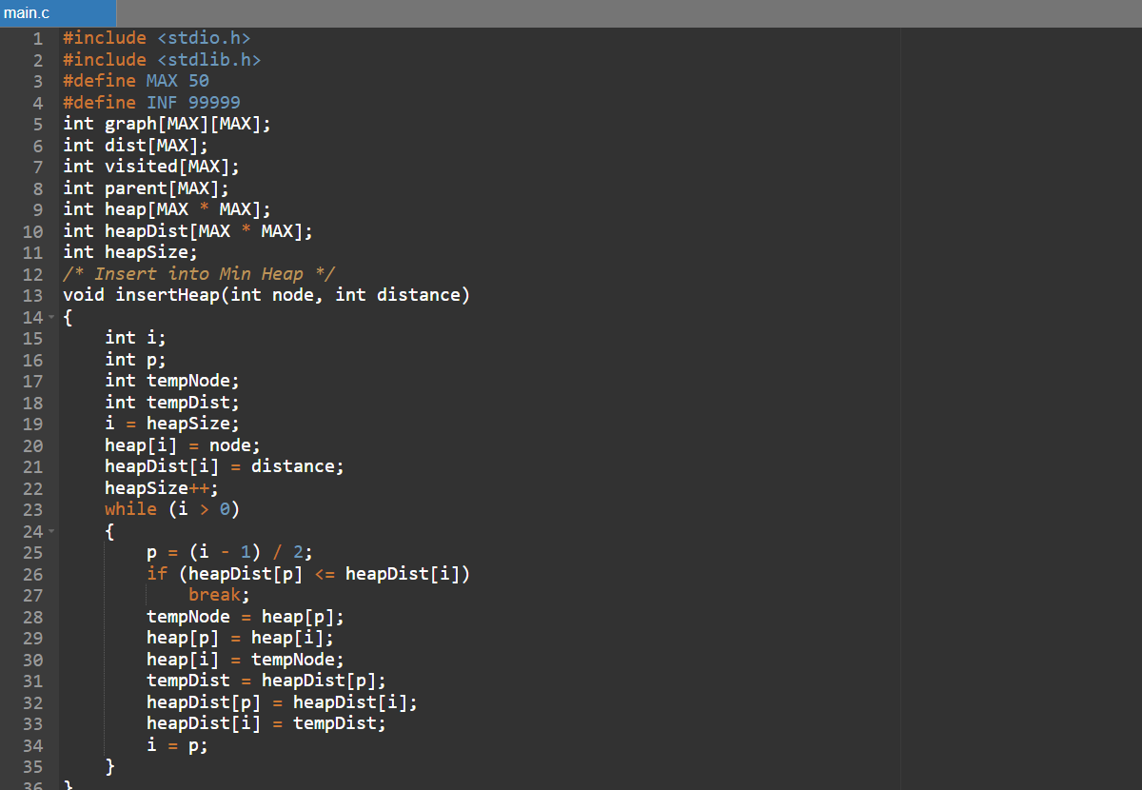
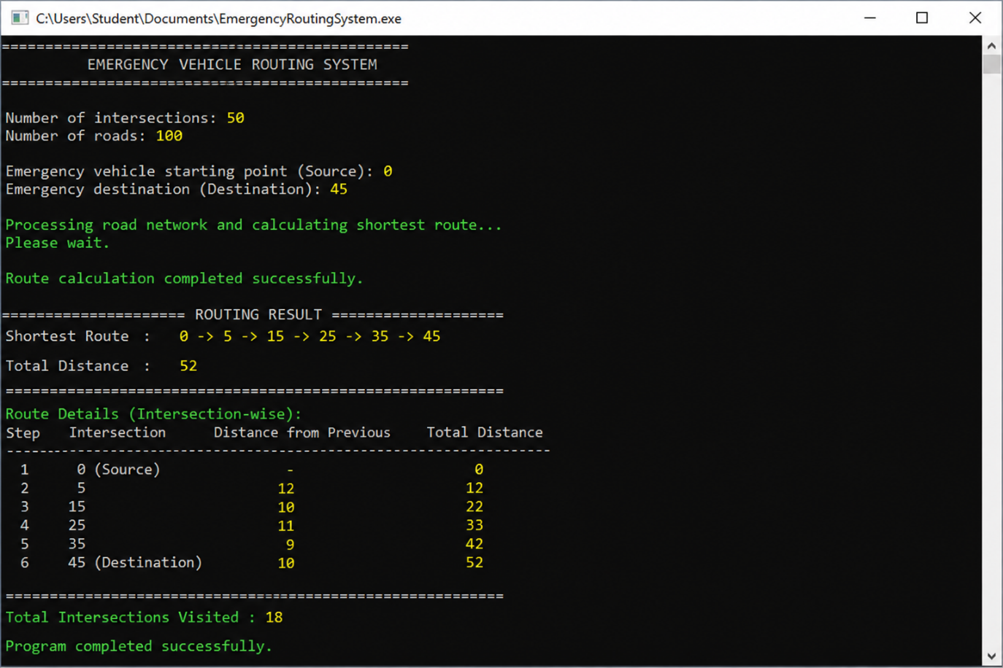
====================================
EMERGENCY ROUTING RESULT
====================================
Shortest Route: 0 -> 5 -> 15 -> 25 -> 35 -> 45
Total Distance: 52
====================================
12. ANALYSIS AND DISCUSSION
12.1 Algorithm Analysis
Dijkstra’s algorithm is appropriate for this application because road distances are represented as non-negative weights.
The algorithm systematically expands the node having the smallest known distance.
The Min-Heap improves the efficiency of finding this node.
12.2 Memory Analysis
Adjacency Matrix
For V nodes:
Space = O(V²)
For a large network, this can require significant memory.
Adjacency List
Space = O(V + E)
Therefore, adjacency lists are generally more suitable for large sparse road networks.
12.3 Time Complexity
Using a Min-Heap:
O((V + E) log V)
where:
- V = number of intersections.
- E = number of roads.
This is more scalable than Floyd-Warshall for individual shortest-path queries on a large graph.
12.4 Comparison of Algorithms
Algorithm | Graph Type | Time Complexity | Suitability
BFS | Unweighted | O(V + E) | Low for weighted roads
Dijkstra | Weighted, non-negative | O((V+E) log V) with Min-Heap | High
Floyd-Warshall | Weighted all-pairs | O(V³) | Low for large networks
Bellman-Ford | Weighted | O(VE) | Less efficient
Dijkstra + Array | Weighted | O(V²) | Moderate
Dijkstra + Min-Heap | Weighted | O((V+E) log V) | Selected

12.5 Engineering Decision
Dijkstra with a Min-Heap was selected because:
- The graph is weighted.
- Road weights are non-negative.
- The system requires shortest-path calculation.
- Min-Heap efficiently identifies the minimum-distance node.
- The approach is suitable for large sparse networks.
- It supports repeated source-destination routing.
12.6 Advantages
The proposed system provides:
- Efficient shortest-path computation.
- Weighted road support.
- Priority-based processing.
- Route reconstruction.
- Unreachable-node detection.
- Support for large network design.
- Potential traffic-aware routing.
- Easy extension to smart-city systems.
12.7 Limitations
The current demonstration has some limitations:
- The C program uses fixed-size arrays.
- The demonstration graph uses an adjacency matrix.
- Real-time external traffic data is not connected.
- Dynamic road closure handling is not implemented.
- The approximately 200 ms target requires actual benchmarking.
- Dijkstra is not suitable for negative edge weights.
- A production system would require stronger error handling and scalability.

13. BROADER CONSIDERATIONS
13.1 Sustainability
Efficient routing can reduce unnecessary travel distance and potentially reduce fuel consumption.
13.2 Environmental Impact
Reduced unnecessary vehicle movement can potentially contribute to lower emissions.
13.3 Social Impact
The system can support emergency services by helping identify efficient routes for ambulances, fire engines and police vehicles.
13.4 Safety
Because emergency routing is safety-sensitive, the system should undergo extensive validation before deployment.
13.5 Economic Impact
Efficient emergency routing can improve vehicle utilization and reduce unnecessary travel costs.
13.6 Smart-City Integration
The system can be extended to integrate with:
- GPS.
- Traffic sensors.
- Smart traffic lights.
- City control centres.
- Digital maps.
- Emergency service databases.

14. CONCLUSION
The Real-Time Emergency Vehicle Routing System Using Dijkstra’s Algorithm, Min-Heap, HashMap and HashSet demonstrates the practical application of graph algorithms and data structures to emergency transportation.
The city road network is represented as a weighted graph, with intersections acting as vertices and roads acting as weighted edges. Dijkstra’s algorithm is used to determine the minimum-cost path, while the Min-Heap provides an efficient priority queue for selecting the next node.
The parent array is used to reconstruct the route, while the visited structure prevents unnecessary processing. HashMap and HashSet concepts provide a foundation for efficient traffic information and visited-node management.
The proposed approach is suitable for applications such as:
- Ambulance routing.
- Fire-engine routing.
- Police emergency routing.
- Disaster response.
- Smart-city traffic management.
- Intelligent transportation systems.
The system can be further improved by integrating real-time traffic feeds, dynamic adjacency lists, GPS, map visualization, route caching and large-scale benchmarking.
Overall, the project demonstrates how appropriate algorithm and data-structure selection can provide an efficient solution to a practical emergency-response problem.

Individual Contribution Summary
P. Sai Ganesh Reddy:
Focused mainly on problem formulation, overall system architecture, Dijkstra’s algorithm and integration of the major components.
Ubed:
Focused on graph implementation and Min-Heap operations required for efficient shortest-path processing.
Harsha:
Focused on traffic-aware concepts, testing, validation, documentation and report preparation.

16. REFERENCES
- T. H. Cormen, C. E. Leiserson, R. L. Rivest and C. Stein, Introduction to Algorithms, MIT Press.
- Robert Lafore, Data Structures and Algorithms in C.
- Ellis Horowitz, Sartaj Sahni and Susan Anderson-Freed, Fundamentals of Data Structures.
- Course materials on Graphs and Shortest-Path Algorithms.
- Course materials on Priority Queues and Min-Heaps.
- Laboratory materials related to Dijkstra’s Algorithm.
- IET Assignment – Real-Time Emergency Vehicle Routing System Using Dijkstra’s Algorithm, Min-Heap, HashMap and HashSet.
- Assignment Format – FINAL, Common Course Assignment Format.

17. ONE-PAGE WRITE-UP
Real-Time Emergency Vehicle Routing System
The Real-Time Emergency Vehicle Routing System is designed to help emergency vehicles such as ambulances, fire engines and police vehicles identify efficient routes through a large road network. In a smart city, emergency vehicles need to reach their destinations quickly, and route selection becomes challenging when roads have different distances and traffic conditions.
The proposed system models the city road network as a weighted graph, where intersections are represented as vertices and roads are represented as edges. The weight associated with each edge represents the distance or effective travel cost of the road. The main objective is to find a minimum-cost route between the emergency vehicle’s current location and its destination.
Dijkstra’s Algorithm is used for shortest-path computation because the road network contains weighted edges. A Min-Heap is used as a priority queue to efficiently select the intersection with the smallest current route cost. The distance array stores the best-known cost for every intersection, while the parent array stores predecessor information and allows the final route to be reconstructed.
The proposed architecture also considers HashMap and HashSet concepts. HashMap can be used to maintain graph and traffic information, while HashSet can be used to track processed intersections. For a traffic-aware system, the effective cost can be calculated as:
Effective Cost = Road Distance + Traffic Cost
The system accepts the number of intersections, number of roads, road information, source and destination. It constructs the graph and initializes the shortest-path information. Dijkstra’s algorithm then processes the graph and updates distances whenever a shorter route is identified.
For a graph containing V intersections and E roads, an adjacency-list representation requires O(V + E) space. Dijkstra’s algorithm using a Min-Heap has time complexity O((V + E) log V). This makes the approach suitable for large sparse road networks.
The system can be applied to ambulance routing, fire-engine routing, police emergency routing, disaster-response systems and smart-city transportation management. Future improvements can include real-time traffic feeds, GPS integration, dynamic road closures, graphical map visualization, route caching and support for multiple emergency vehicles.
Overall, the project demonstrates the practical application of graphs, Dijkstra’s algorithm, Min-Heaps, HashMaps and HashSets to solve an important real-world emergency transportation problem.

Common Assessment Rubric

Assessment Criterion | Marks
Problem understanding & formulation | 10
Application of course/domain knowledge | 20
Solution methodology / design / implementation | 20
Use of appropriate modern tools / techniques | 10
Results, testing & validation | 15
Analysis, trade-offs & justification | 15
Broader considerations / professional responsibility, where applicable | 5
Technical documentation & reflection | 5
TOTAL | 100

CO–PO–Assessment Mapping

Assessment Component | CO | PO(s) | Bloom's Level | Marks
Problem formulation |  |  | L3/L4 | 10
Application of knowledge |  |  | L3/L4 | 20
Solution / Design / Implementation |  |  | L4/L5/L6 | 20
Modern tool usage |  |  | L3/L4 | 10
Validation |  |  | L4/L5 | 15
Analysis & justification |  |  | L4/L5 | 15
Broader considerations |  |  | L4/L5 | 5
Documentation & reflection |  |  | L3/L4 | 5
Note: Faculty shall map only the POs and Bloom's levels genuinely assessed by the particular assignment. Every assignment is not required to map to every PO.

Faculty Evaluation & Continuous Improvement CO Attainment

Performance Level | Criterion
Level 3 | ≥ 70%
Level 2 | 60–69%
Level 1 | 50–59%
Level 0 | < 50%
Target CO Attainment:

Actual CO Attainment:

Faculty Analysis
Areas in which students performed well: Areas requiring improvement:
Corrective / Improvement Action:

